Дата: 16.11.2021 Клас: 6-А Предмет : Англійська мова

Тема: Шкільні правила.

Вчитель: Глуговська Л.Г.

**Хід уроку**

***1.Greeting***

Good morning, children! How are you?

I see you are ready to begin our lesson. I hope you’ll work well and get good marks.

***2. Check homework***

*Прочитайте текст, доповніть його пропущеними словами та запишіть.*

У цій вправі Вам допоможе текст в підручнику на сторінці 57, який був домашнім для прочитання.

Tuesday, the sixteenth of November

Classwork

Exercise 39

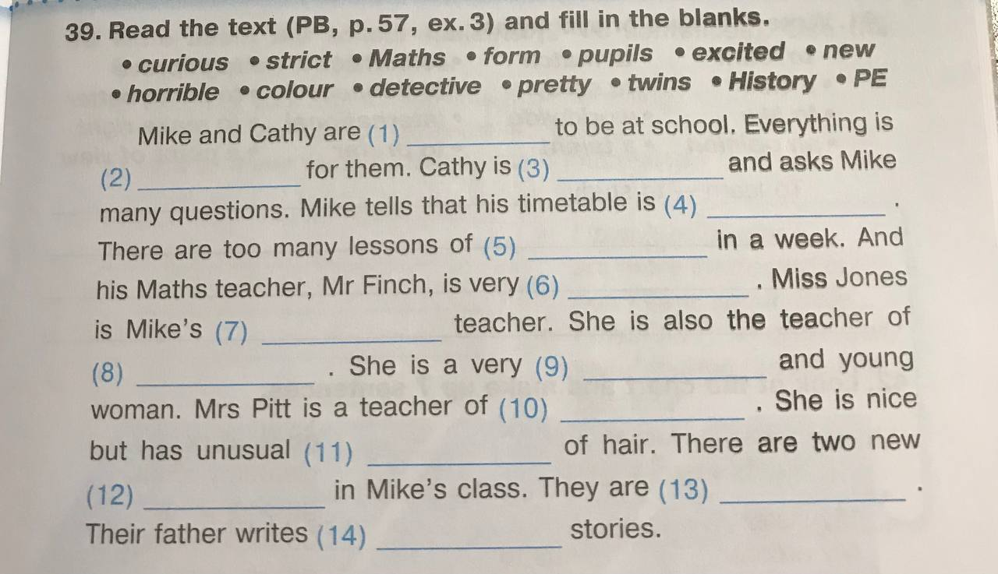

***3. Reading***

*Прочитай уважно електронне письмо від Джеймса.*

Hi Luis!

My name is James Farrell. I’m your new e-pal. I’m from Galway in Ireland. I have got blue eyes and light brown hair. My hair is quite long. I’m not tall.

My school is called Manor Park. It isn t a very big school. It is only got 400 students. My favourite subjects are maths and science. I’ve got maths on Monday and Wednesday and science on Tuesday and Friday. I also like IT. At school we have got a special computer room.

After school we have got a lot of homework. But I have also got time for other activities. For example, I’m in the school drama club. At the weekend I’ve got guitar lessons.

Write back soon and tell me about yourself.

All the best.

James

***4. Speaking***

*Усно дайте відповіді на запитання.*

1. What is the name of your school?
2. Is your school big or small?
3. What are your favourite subjects?
4. Have you got a computer room at school?
5. Have you usually got a lot of homework?
6. Have you got any special hobbies or activities after school?

***5.Homework***

Домашнє завдання:

1. Виконати письмово вправу 39.

2. Підготуватися до підсумкової роботи, повторити стр. 48-64.

**Надіслати виконані вправи у Вайбер (0964124047) – Людмила Григорівна або прикріпити на Human.**